**SHIMONI DEMONSTRATION SCHOOL -KIRA**

**END OF YEAR EXAMINATION 2022**

**CLASS : PRIMARY SIX**

**SUBJECT : SCIENCE**

**DURATION : 2 HRS -15MINS**

**NAME:____________________________________________________________________**

**Read the following instructions carefully.**

1. This paper is made up two section: A and B
2. Section A, has 40 short answer questions (40 marks)
3. Section B, has 15 questions. (60 marks)
4. Answer all questions. All answers for section A and B must be written in the spaces provided.
5. All answers must be written using a blue or black ball-point pen or ink. Diagrams should be drawn in pencil.
6. Unnecessary alteration of work will lead to loss of marks.
7. Any handwriting that cannot easily be read may lead to loss of marks.
8. Do not fill anything in the boxes indicated for official use only.

|  |  |  |
| --- | --- | --- |
| **FOR OFFICIAL USE** | | |
| **SECTION** | **MARKS** | **T/L MARKS** |
| A |  |  |
| B |  |  |
| **TOTAL** |  |  |

***SECTION A***

1. Which food value do we get from eating honey?

_________________________________________________________________________________________________

2. State any one danger of alcoholism to an individual.

_________________________________________________________________________________________________

3. How is a dustbin useful in a school?

_________________________________________________________________________________________________

4. How is the seed below dispersed?

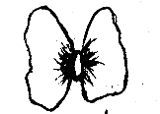

________________________________________________________________________________

5. Differentiate between a scald and a burn.

_________________________________________________________________________________________________

6. State one role of an individual in promoting PHC.

_________________________________________________________________________________________________

7. Why is distilled water not good for drinking?

_________________________________________________________________________________________________

8. Give one example of natural fibre.

_________________________________________________________________________________________________

9. Name the type of cloud that brings rain to farmers’ crops.

_________________________________________________________________________________________________

10. Why do farmers rear rabbits?

_________________________________________________________________________________________________

11. Name any one natural manure farmers use to improve with soil fertility.

_________________________________________________________________________________________________

12. What is docking as used in sheep keeping?

_________________________________________________________________________________________________

13. How does painting of materials made of iron helpful in prevention of rusting?

_________________________________________________________________________________________________

14. Name any one dangerous substance found in tobacco smoke. _________________________________________________________________________________________

15. How do mushrooms reproduce?

_________________________________________________________________________________________________

16. State any one raw material for respiration.

_________________________________________________________________________________________________

17. Give one class of vertebrate.

_________________________________________________________________________________________________

18. State one disease in cattle.

_________________________________________________________________________________________________

***Use the diagram of a latrine below to answer questions 19 and 20***.

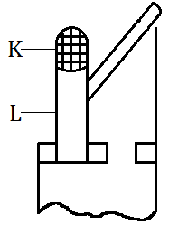

w

19. Name part marked L.

_________________________________________________________________________________________________

20. How useful is part K on the latrine shown above?

_________________________________________________________________________________________________

21. State any one agent of soil erosion.

_________________________________________________________________________________________________

22. Why are bats called nocturnal?

_________________________________________________________________________________________________

23. Name the garden tool below.

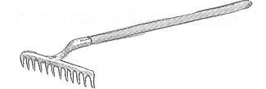

_________________________________________________________________________________________________

24. How do fish help to control the spread of malaria?

_________________________________________________________________________________________________

25. Apart from making matter to expand, give another effect of heat on matter.

_________________________________________________________________________________________________

26. Give the similarity between wind vane and wind sock.

________________________________________________________________________________________________

________________________________________________________________________________________________

27. What is pollution?

_________________________________________________________________________________________________

_________________________________________________________________________________________________

28. Which vector spreads malaria germs to people?

_________________________________________________________________________________________________

_________________________________________________________________________________________________

29. State any one reason why bees can swarm.

_________________________________________________________________________________________________

_________________________________________________________________________________________________

30. State any one way in which bacteria are dangerous to people.

_________________________________________________________________________________________________

_________________________________________________________________________________________________

31. Name the life cycle of an insect shown below.

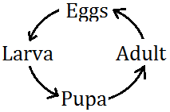

_________________________________________________________________________________________________

32. Give one characteristic of a physical change.

_________________________________________________________________________________________________

_________________________________________________________________________________________________

33. Name one mineral salt that can be lost in the body during dehydration.

_________________________________________________________________________________________________

________________________________________________________________________________________________

34. Apart from mulching, give another method used to control weeds in the garden.

_________________________________________________________________________________________________

_________________________________________________________________________________________________

35. How does the use of biogas help in the conservation of trees in the environment?

_________________________________________________________________________________________________

_________________________________________________________________________________________________

36. Why do some objects float on water?

_________________________________________________________________________________________________

_________________________________________________________________________________________________

37. What is the importance of curling to a millipede?

_________________________________________________________________________________________________

38. Which body organ do we use for feeling?

_________________________________________________________________________________________________

39. State the importance of prop roots to a maize plant.

________________________________________________________________________________________________

40. Give one example of primary sex characteristic.

_________________________________________________________________________________________________

***SECTION B***

41. (a) State two physical differences between veins and arteries.

(i) _____________________________________________________________________________________________

_________________________________________________________________________________________________

(ii) ____________________________________________________________________________________________

_________________________________________________________________________________________________

(b) Which type of blood is transported by most blood vessels with valves?

_________________________________________________________________________________________________

(c) Name any one waste material transport by blood.

_________________________________________________________________________________________________

42. (a) Write any two components of a first aid box.

_________________________________________________________________________________________________

_________________________________________________________________________________________________

(b) State two reasons why accident victims should be given first aid.

_________________________________________________________________________________________________

_________________________________________________________________________________________________

43. (a) Give the use of soap when washing.

_________________________________________________________________________________________________

(b) Identify any two activities involved in cleaning clothes.

(i) _____________________________________________________________________________________________

(ii) ____________________________________________________________________________________________

(c) State any one danger of putting on dirty clothes.

_________________________________________________________________________________________________

44. ***Complete the table about immunization***.

|  |  |  |
| --- | --- | --- |
| **Vaccine** | **Diseases protected** | **Site** |
| Measles vaccine | Measles |  |
|  | Tuberculosis | Right upper arm |
| Polio vaccine | Polio |  |
| DPT vaccine |  | Left upper thigh |

45. ***Match the disease in A with the vector in B***.

**A B**

Typhus fever Houseflies

Bilharziasis Ticks

Dysentery Culex mosquito

Elephantiasis Water snails

(i) Typhus fever _____________________________________________________________________

(ii) Bilharziasis _____________________________________________________________________

(iii) Dysentery _____________________________________________________________________

(iv) Elephantiasis ____________________________________________________________________

46. ***Use the diagram below to answer questions that follows***.

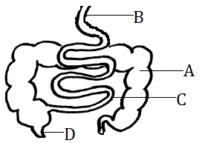

(a) To which body system does the above diagram belong?

____________________________________________________________

(b) Name the part marked;

(i) B _____________________________________________________________

(ii) D_____________________________________________________________

(c) What important process takes place in part C?

_________________________________________________________________________________________________

47. (a) What is first aid?

_________________________________________________________________________________________________

_________________________________________________________________________________________________

(b) Give one quality of a good first aider.

________________________________________________________________________________________________

(c) State one injury that requires the use of a stretcher.

_________________________________________________________________________________________________

(d) Give one major reason for giving first aid.

_________________________________________________________________________________________________

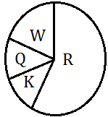48. ***The diagram below represents the components of air. Study it and answer questions that follow***.

(a) Name the gases represented by letters.

(i) R __________________________________________________________________________________________

(ii) W _________________________________________________________________________________________

(b) Which gas from the above diagram is needed during the following?

(i) Photosynthesis ___________________________________________________________________________

(ii) Seed germination ________________________________________________________________________

49. (a) Name the hormones that cause secondary characteristics in:

a) Boys_______________________________________________________

b) Girls_______________________________________________________

(b) Give any two secondary sex characteristics common in both boys and girls.

_________________________________________________________________________________________________

(d) Which birth control method is artificial and permanent?

_________________________________________________________________________________________________

50. (a) Write PHC in full.

_________________________________________________________________________________________________

(b) Which element of PHC can be promoted by:

(i) Keeping rubbish in dustbin?

_________________________________________________________________________________________________

(ii) Cutting fingernails short?

_________________________________________________________________________________________________

(c) How does boiling make water safe for drinking?

_________________________________________________________________________________________________

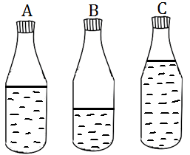51. ***Study the diagram below of bottles with water and answer questions that follow***.

(a) Which bottle will produce the highest pitch when air is blown in the bottles?

_________________________________________________________________________________________________

(b) Give a reason for your answer in (a) above.

__________________________________________________________________________________________________________________________________________________________________________________________________

(c) Give any two examples of musical instruments?

(i) _____________________________________________________________________________________________

(ii) ____________________________________________________________________________________________

52. ***Study the diagram below carefully and use it to answer the questions that follow***.

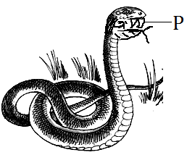(a) Name the structure marked P._____________________________________

b) What type of snake has such type of structures named in (a) above?

_____________________________________________________________________

(c) To which group of cold blooded animals does the animal drawn above belong?

_________________________________________________________________________________________________

(d) Give one reason why snakes bite?

_________________________________________________________________________________________________

_________________________________________________________________________________________________

53. (a) Name one type of cattle.

_________________________________________________________________________________________________

(b) Give one advantage of artificial insemination.

_________________________________________________________________________________________________

_________________________________________________________________________________________________

(c) Name the method used to give liquid medicine to cattle.

_________________________________________________________________________________________________

(d) Name one viral disease of cattle.

_________________________________________________________________________________________________

54. (a) Name the part marked X below.

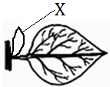

**X**

________________________________________________________________________

(b) How is the above leaf important to a growing plant?

_________________________________________________________________________________________________

(c) What is photosynthesis?

__________________________________________________________________________________________________________________________________________________________________________________________________

(d) Name the byproduct of photosynthesis.

_________________________________________________________________________________________________

55. ***The diagram below shows a method of making alcohol. Use it to answer questions that follow***.

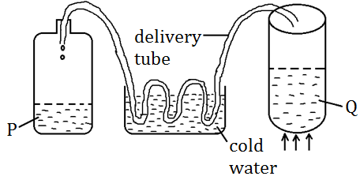

(a) What method has been used in the above diagram?

_________________________________________________________________________________________________

(b) Name any one substance that can be used in the container marked Q.

_________________________________________________________________________________________________

(c) Apart from the above method, name the other method of making alcohol.

_________________________________________________________________________________________________

_________________________________________________________________________________________________

(d) Give any one medical use of substance P.

_________________________________________________________________________________________________

_________________________________________________________________________________________________

***\*\*\*\*\*GOD BLESS\*\*\*\*\****